**Stored Procedures**

1. Find the name of the Database you are using.

Query Goes Here

USE CityJailSummerDB

SELECT DB_NAME() AS DataBaseName

Output Goes Here

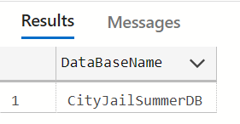

1. Find the name of the Database using parameter @id

Query Goes Here

USE CityJailSummerDB

SELECT DB_NAME(database_id) AS [Database], database_id

FROM sys.databases;

SELECT DB_NAME(6) AS [Database]

Output Goes Here

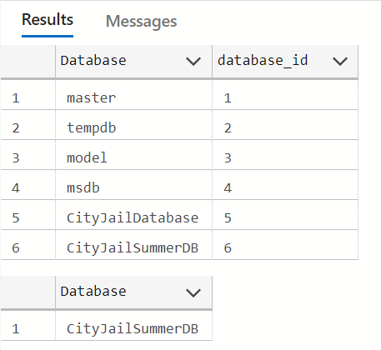

1. Create a stored procedure that returns all officers (first and last names supplied), their precinct, badge, and their status. This procedure does not use any parameters.

Query Goes Here

CREATE PROCEDURE spGetOfficers

AS

BEGIN

SELECT [first], [last], precinct, badge, [status] from officers

END

Output Goes Here

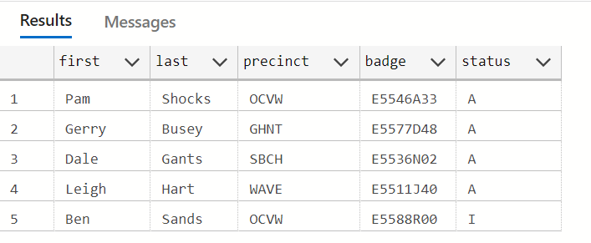

1. Create a procedure that returns two result sets:
   1. Top 10 rows showing officer id, his first and last name
   2. Top 10 rows showing crime id, and its classification.

Query Goes Here

CREATE PROCEDURE spGetOfficersAndCrimes

AS

BEGIN

SELECT TOP 10 officer_id, [first], [last] FROM officers

SELECT TOP 10 crime_id, classification FROM crimes

END

Output Goes Here

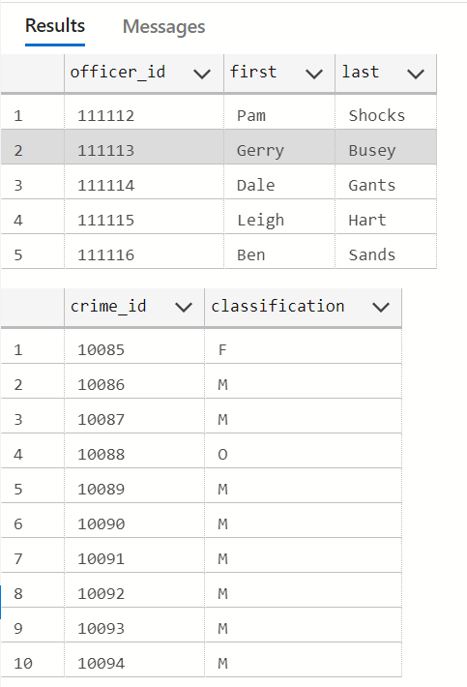

1. Create a stored procedure that returns information for a specific criminal by passing values for the criminal’s first name and last name. This procedure accepts only exact matches for the parameters passed.

Query Goes Here

CREATE PROCEDURE spSpecificCriminals

@first VARCHAR(15),

@last VARCHAR(10)

AS

BEGIN

SELECT * FROM criminals

WHERE [first] = @first AND [last] = @last

END

Output Goes Here

spSpecificCriminals Sam, Phelps

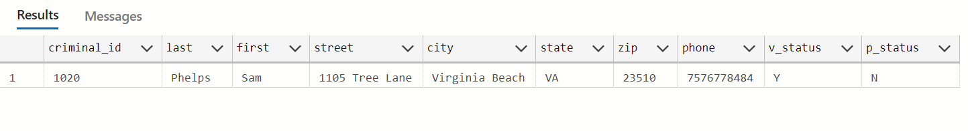

1. Create a stored procedure that returns information for criminals by passing full or partial values for the criminal’s first name and last name. This procedure pattern matches the parameters passed or, if not supplied, uses the preset default (last names that start with the letter D).

Query Goes Here

CREATE PROCEDURE spPartialCriminals

@first VARCHAR(15) = N'%',

@last VARCHAR(10) = N'D%'

AS

BEGIN

SELECT * FROM criminals

WHERE [first] LIKE @first AND [last] LIKE @last

END

Output Goes Here

